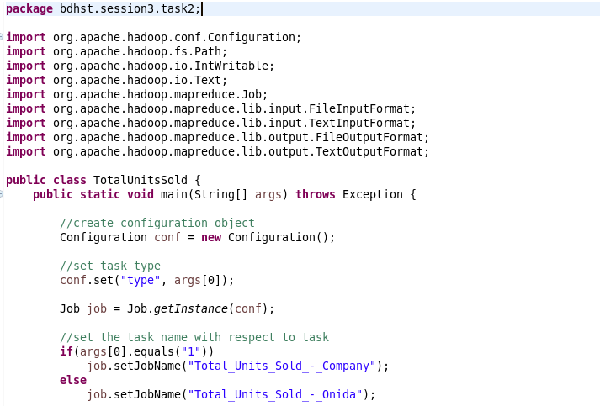 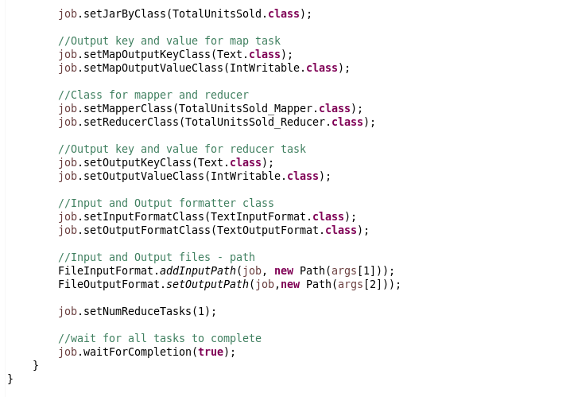

Txcvxcvxcv

**Mapper Class:**

**TotalUnitsSold_Mapper.java**

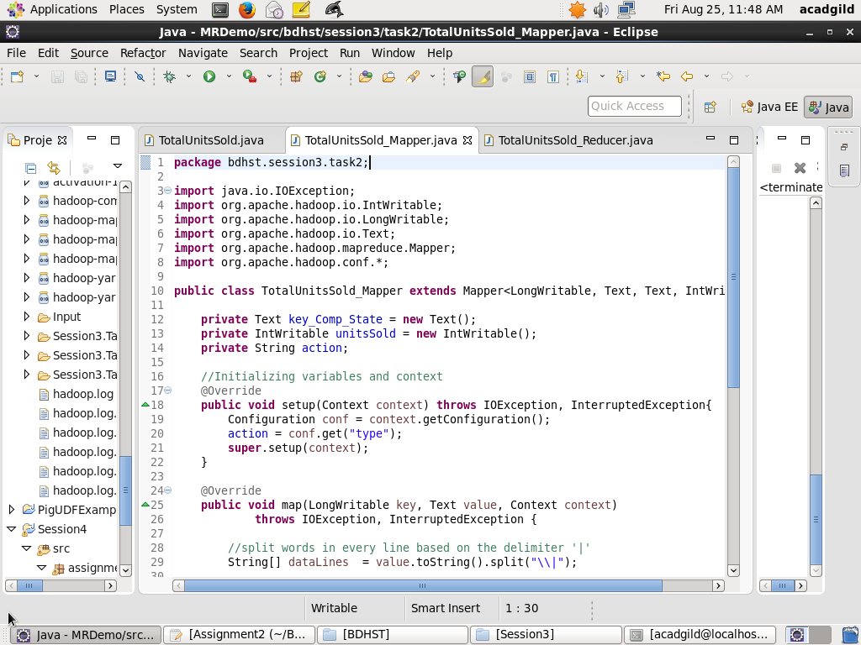

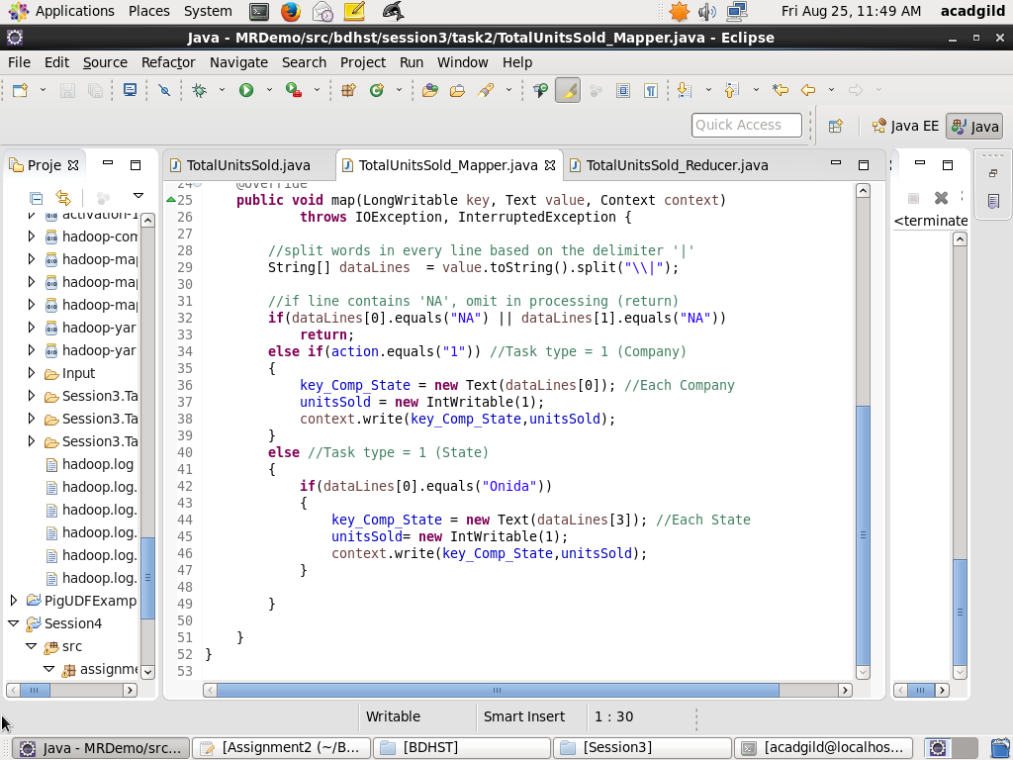

**Reducer Class:**

**TotalUnitsSold_Reducer.java**

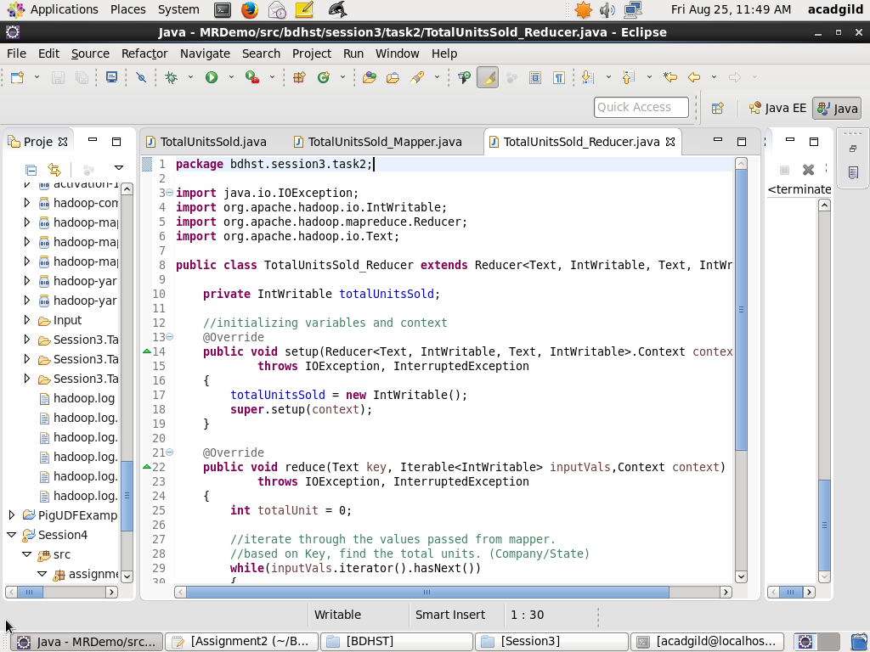

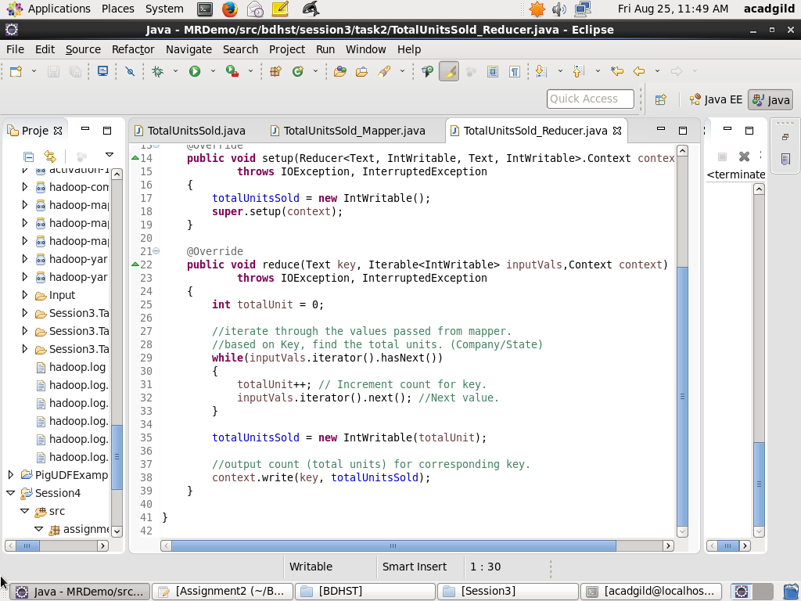

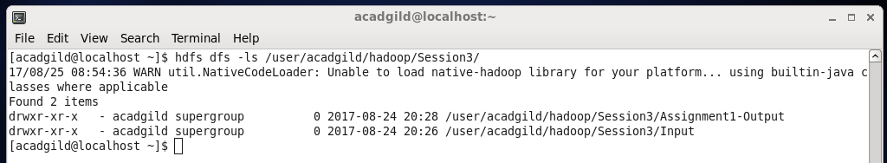

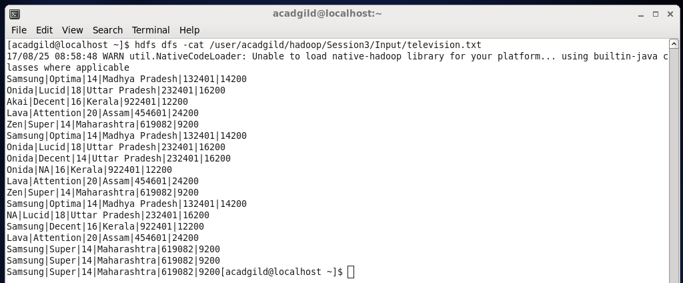

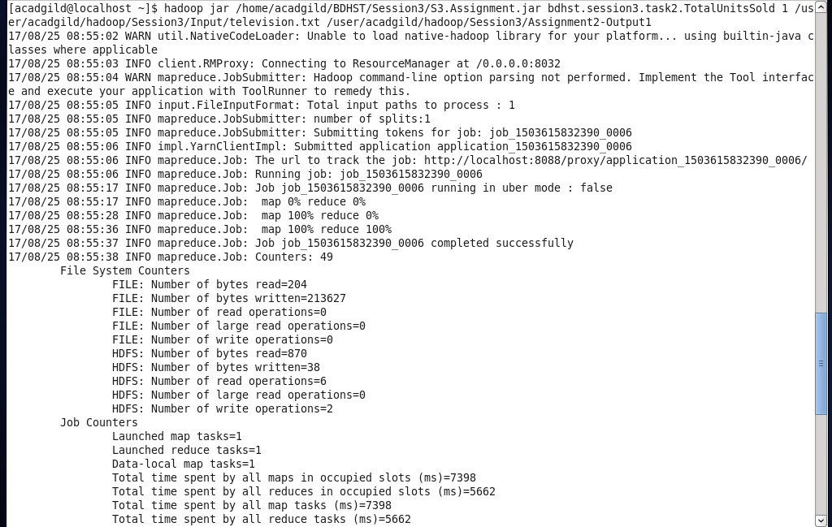

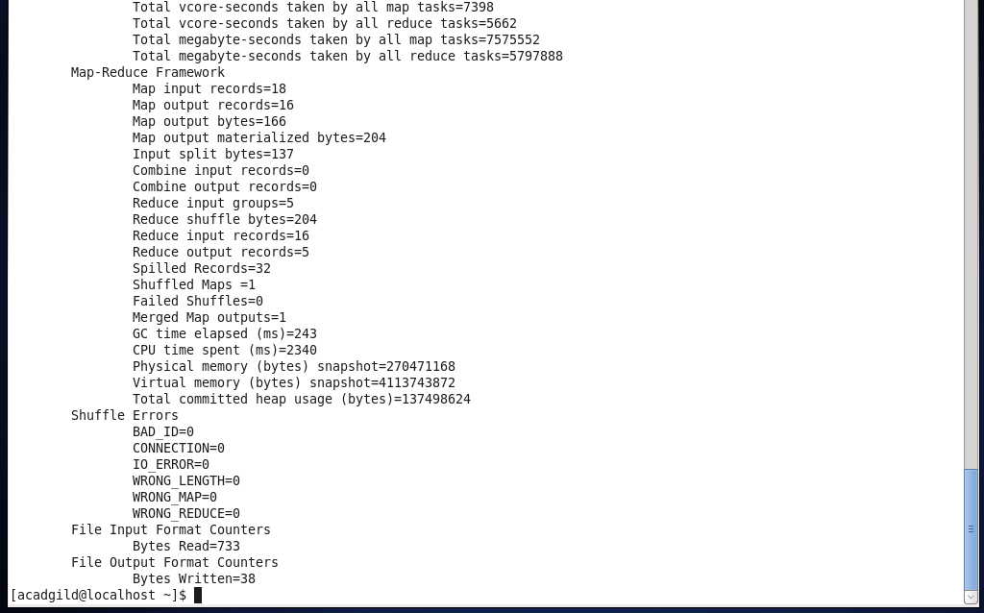

1. Displaying contents of Output folder (Assignent2-Output1).
2. Displaying contents of Result file (part-r-00000) in Assignent2-Output1.

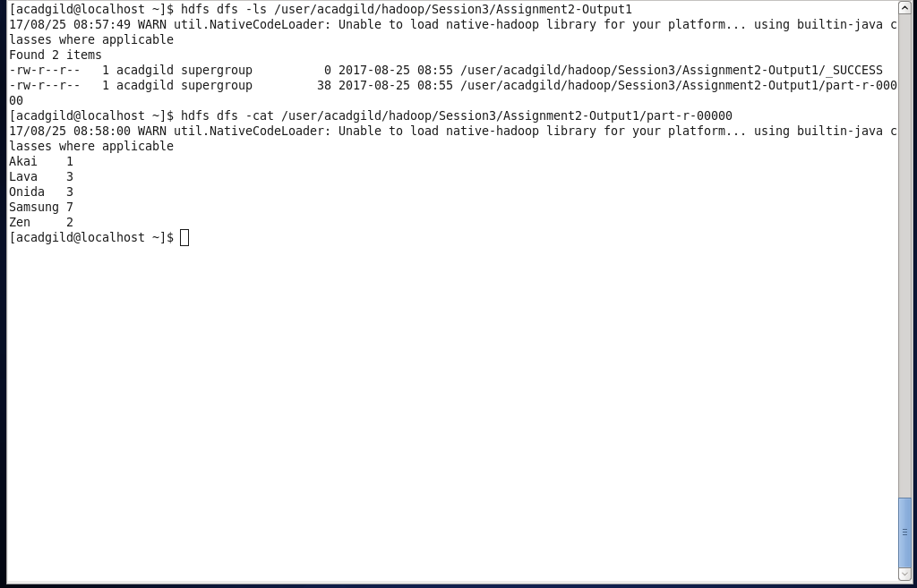

**OUTPUT for Task2:** Calculate the Total Units sold for Onida in each state.

1. The .jar file containing the Program to find the Total Units sold for each Company and each state for Onida using the foll. format:

Hadoop jar *[Path of .jar file location in local FS] [Path of Main Class in jar] [Task to execute (1-Company, 2-Onida)] [Path of Input Dataset] [Path in HDFS for Output Storage]*

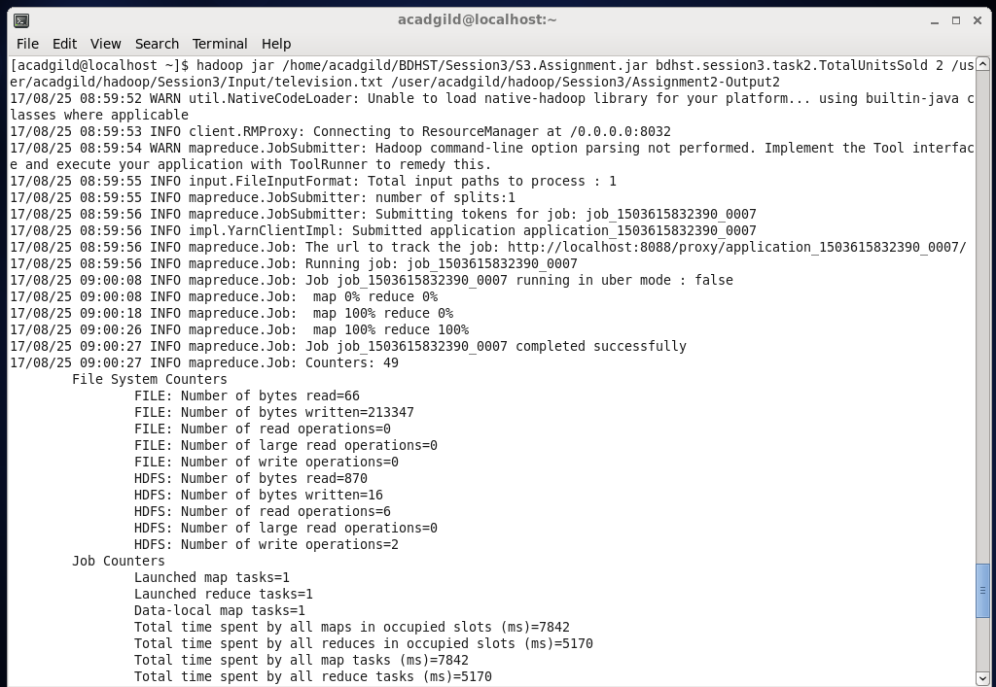

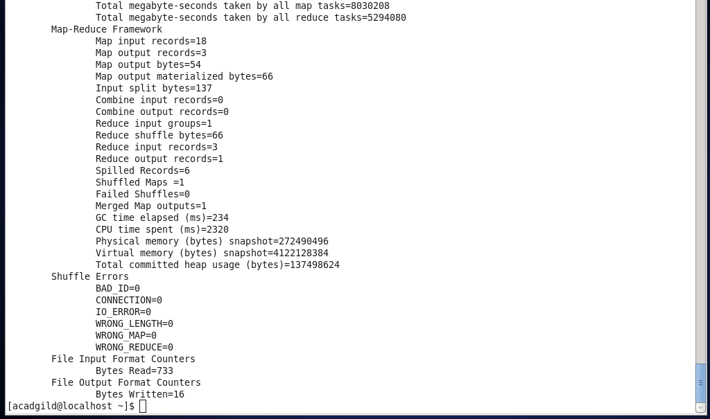

1. Listing contents of ~/Session3 that holds the Input Dataset to be used in the program.
2. Displaying contents of Output folder (Assignment2-Output2).
3. Displaying contents of Result file (part-r-00000) in Assignment2-Output2.

